ARANMORE CATHOLIC COLLEGE

YEAR 12 PHYSICS 3A3B

TEST 6: - ASTROPHYSICS

NAME: _______________________________________ MARK:
/50

Instructions:

- Answer all questions in the spaces provided.
- Show all working out to get full marks as shown in brackets after each question.
- Calculators as per Curriculum Council guidelines are permitted.
- Answers must be in blue or black ink.

QUESTIONS:

- There are six ‘flavours’ or types of quark; the up, down, charm, strange, top and bottom type quarks. Three of these quarks (up, charm and top) each have a charge of +2/3e, while the other three have a charge of -1/3e (where e = 1.6 x 10⁻¹⁹ C). Their antiparticles (antiquarks) have the same magnitude of charge, but of opposite sign. Before the discovery of quarks, it was believed that the smallest fundamental charge was that of an electron or a proton with a value of ±1e. All hadrons (baryons and mesons) are composed of quarks and yet all have either zero or an integer value of e charges. Show clearly how this is the case for the two types of hadrons.
(5 marks)

- Apart from the quarks which the hadrons (baryons and mesons) are composed, there are two other types of fundamental particles. Name these two types of fundamental particles and give two examples of each. (6 marks)

- The Hubble telescope was launched by NASA in 1990 and has orbited the Earth since at an average distance of about 570 km above the Earth’s surface. It has beamed hundreds of thousands of images back to Earth, shedding light on many of the great mysteries of astronomy. Its gaze has helped determine the age of the universe, the identity of quasars and the existence of dark energy. On Earth the largest (Keck) telescopes have a 10 m diameter mirror and are located 4100 m above sea level on a dormant volcano.

a) Why are telescopes built so far above sea level? (1 mark)

b) Why did NASA put the Hubble telescope into space when bigger telescopes exist on Earth?
(2 marks)

c) It has been stated that the Hubble telescope allows us to look back in time to billions of years ago. Explain this statement. (2 marks)

- Georges Lemaître (in 1927) proposed a theory of the nature of the Universe (now known as the ‘Big Bang’ theory), as a logical extension of Einstein’s General Theory of Relativity. ‘Big Bang’ was not Lemaître’s term – this name was coined by a renowned astronomer, Sir Fred Hoyle who was mocking the idea. Astronomers now accept Lemaître’s theory as correct.

a) Briefly describe the essential features of the big bang theory. (2 marks)

b) What evidence has been discovered to support this theory? (4 marks)

c) Describe two possible models that have been proposed for the ultimate fate of the universe.
(2 marks)

- If you were able to observe a passenger holding a clock in a spaceship traveling at 99% of the speed of light relative to your inertial frame of reference, two ‘unusual’ observations would be noted – ‘unusual’ in the sense that neither would be observed at everyday (low) speeds.

a) Describe these two observations. (2 marks)

b) How would you appear to the passenger? (2 marks)

c) What is an inertial frame of reference? (2 marks)

- The visible emission spectrum of a hydrogen atom has three bright lines – red, blue-green, and violet. The blue-green line is caused by the emission of a photon as it moves from energy level 4 to energy level 2. The energy of each level (in eV) can be calculated using the formula:
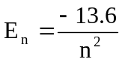
- What is the energy of the photon emitted (in eV) that causes the blue-green line? (2 marks)

- What is the wavelength of this line in nanometres? (2 marks)

The blue-green line of the hydrogen spectrum from a close galaxy is observed to be shifted to 537.4 nm. For close galaxies receding at a relatively low velocity, the recessional velocity (v) of the galaxy can be calculated using this redshift by the equation: 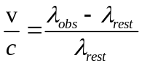

- Calculate the recessional velocity of the galaxy. (in km s⁻¹). (3 marks)

- Using Hubble’s law, calculate the distance in light-years to this relatively close galaxy using its recessional velocity from part (c). (1megaparsec = 3261636.26 light-years)

Hubble’s law: v = H₀ D

where v is the velocity (in km s⁻¹), D is the distance ( megaparsecs Mpc ), and H₀ is Hubble’s constant [ H₀ = 74.2 ± 3.6 (km s⁻¹ Mpc⁻¹) ]. (2 marks)

- Before satellites were available, stellar parallax was measured from Earth using annual parallax as the Earth orbits around the sun. (1 parsec = 3.26156 light-years and is also the distance for which the annual parallax is 1 arcsecond. 1 Earth year = 365.25 solar days.)
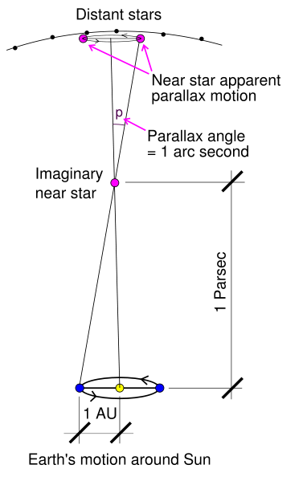

a) If the imaginary star in the diagram above is 1 parsec away, how distant is this star in metres? (2 marks)

b) Calculate the radius of the Earth’s orbit around the sun in metres. (2 marks)

- The following graph shows the factor by which mass increases with increasing velocity approaching the speed of light.

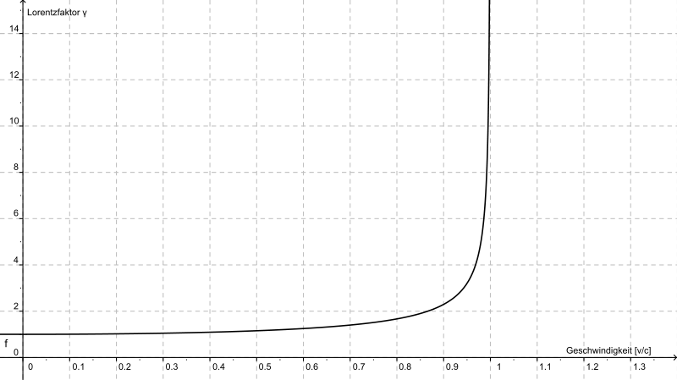
Mass increase
v/c

A proton of mass 1.67 x 10⁻²⁷ kg is accelerated in the Large Hadron Collider until it reaches 0.95c (c = speed of light).

a) Estimate the new mass of the proton from the graph. (2 marks)

b) What is the reason for this apparent increase in mass? (1 mark)

Einstein derived the mathematical equation showing how mass changes with speed, where m_{o} is the rest mass and m_{v} is the mass when moving (in kg).
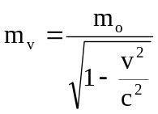

c) Using the equation above, calculate the mass of the proton when it is moving at 0.99c.
(2 marks)

d) Why is it impossible for the proton to travel at or faster than the speed of light? (2 marks)

******************************************************************

END OF TEST

